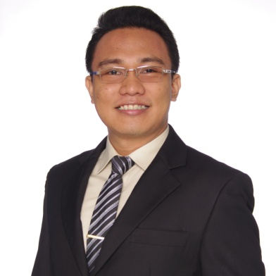**Carl Andrew A. Lara**

**Address: Negros Oriental, Dumaguete City**

**Mobile Number: 09261223542 / 09176505423**

**E-mail Address: adalimz@gmail.com**

|  |
| --- |
| CAREER OBJECTIVE |

To secure a position that will lead to a lasting and fruitful working relationship with colleagues and clients of the company.

|  |
| --- |
| EDUCATION |

2010-2014 **Silliman University**

College of Business Administration

Bachelor of Business Administration - Major in Management

Dumaguete City

2006-2010 **Saint Louis School Don Bosco**

Dumaguete City

|  |
| --- |
| Trainings and Experiences |

2010-2011 **Customer Service Specialist – Teller**

**Security Bank – Dumaguete Branch**

* August 2014 - December 2014
* Processed an average of 130 transactions for 5 days a week.
* Responsible for daily servicing of monetary deposit requirements of all bank customers. Included are processing of payments, receipts, deposits, withdrawals, encashments, and other financial transactions.
* Reports fraud/ potential fraud
* Attended Security Bank Anti-Money Laundering Seminar

2013-2014 **On-the-Job training - Bank of the Philippines, – Perdices Branch,**

**Dumaguete City**

**November 18, 2013 to February 3, 2014**

* Releasing of ATM cards to clients
* Vouching of checks
* Serializing of foreign currency
* Assisting clients with inquiries on which bank employee to approach for their transaction.
* Assisting bank employees upon request

|  |
| --- |
| EXAMS PASSED |

APRIL 6, 2014

Civil Service Exam -PPT

PROFESSIONAL LEVEL

|  |
| --- |
| CHARACTER REFERENCES |

**Leodegario P. Rosales**

Senior Manager

Bank of the Philippine Islands

Gov. Mariano Perdices cor. Legaspi Streets, Dumaguete City

Office Contact No. 225-4845/225-4816

Contact No. 09167548349

**Dulce Maria Rosario S. De Guzman**

Guidance Councilor

Silliman University College of Business Administration Guidance Councilor

Dumaguete City

Office Contact No. 422-6002 Loc. 324

Contact No. 09063047460

**Daisy Lumen**

Branch Service Officer

Security Bank – Dumaguete Branch

Contact No. 09155153503